Proofreading on the Multivariate Note

BHARGAV PARSI(804945591)

# Mistake 1

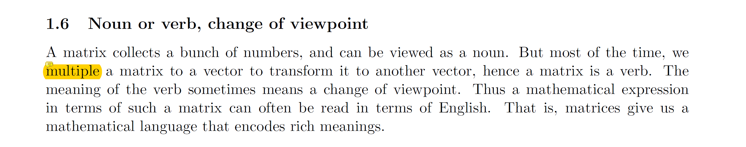

Correction 🡪 change **multiple** to **multiply.**

# Mistake 2

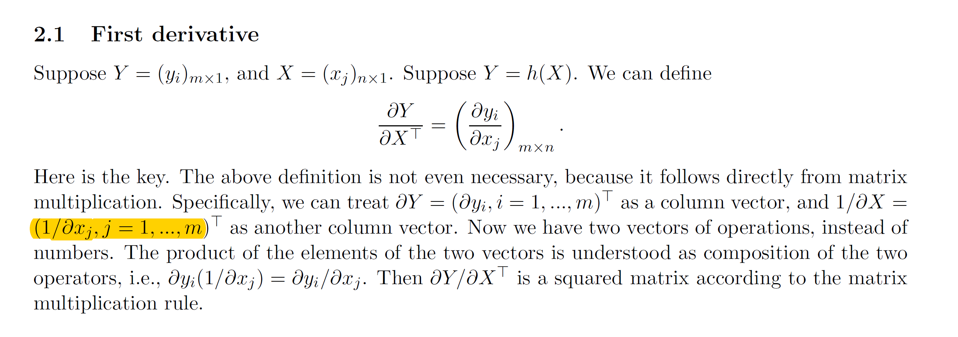

**(1/δxj, j = 1,..m)T** 🡪 **(1/δxj, j = 1,..n)T**

Because X is a n x 1 matrix.

# Mistake 3

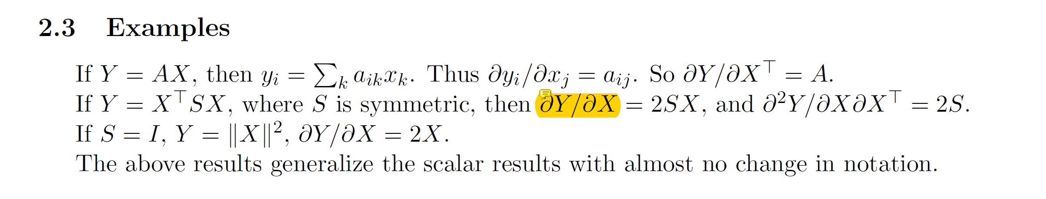

🡪 **T**

We always mean to use Transpose in the first derivative.

# Mistake 4 and 5

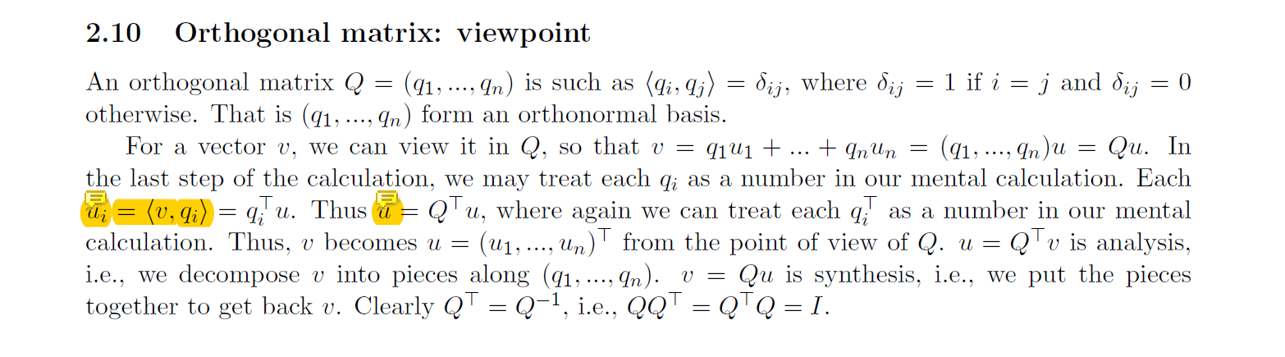

**ui = <v,qi> 🡪 v = < ui , qi >**

**u = QT u 🡪 v = QT u**

The above two equations are mistakes because v is defined as the inner product of q and u.

# Mistake 6

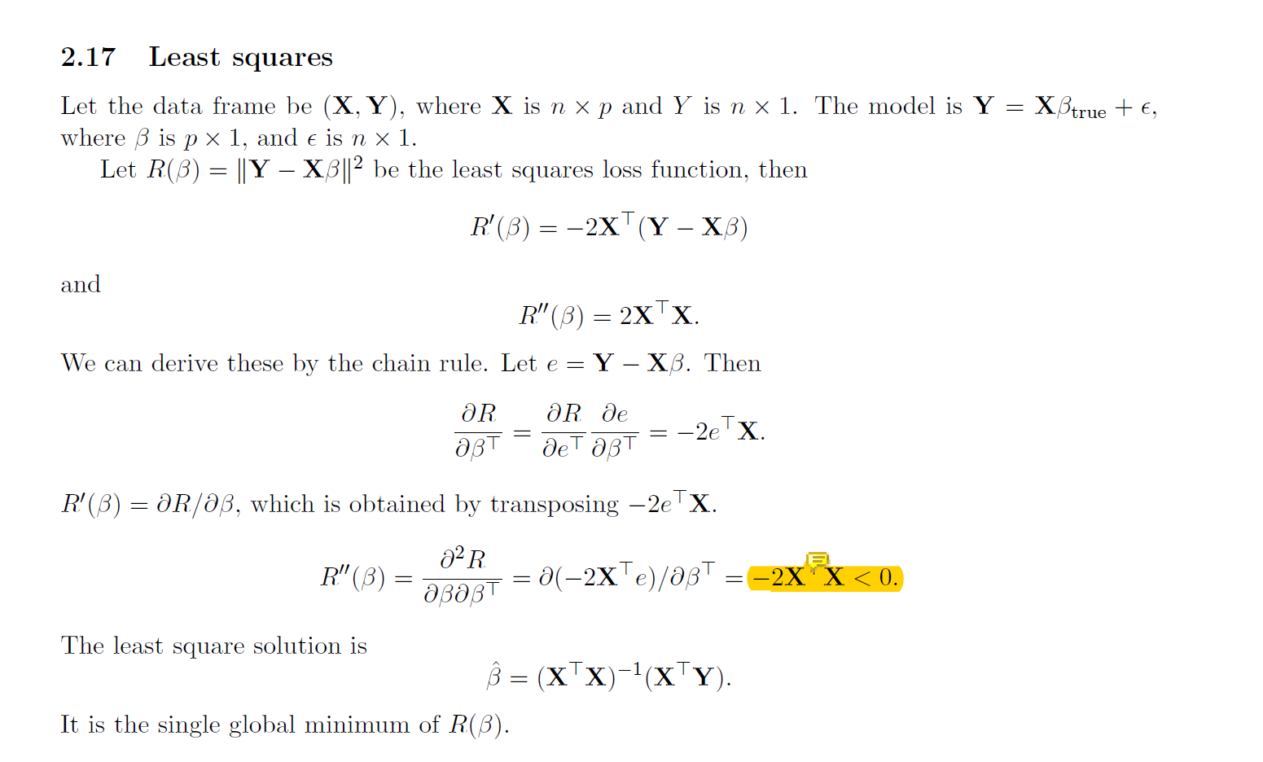

Minumum will be obtained only if double derivative is > 0.

**-2XTX < 0** 🡪 **2XTX > 0**

# Mistake 7

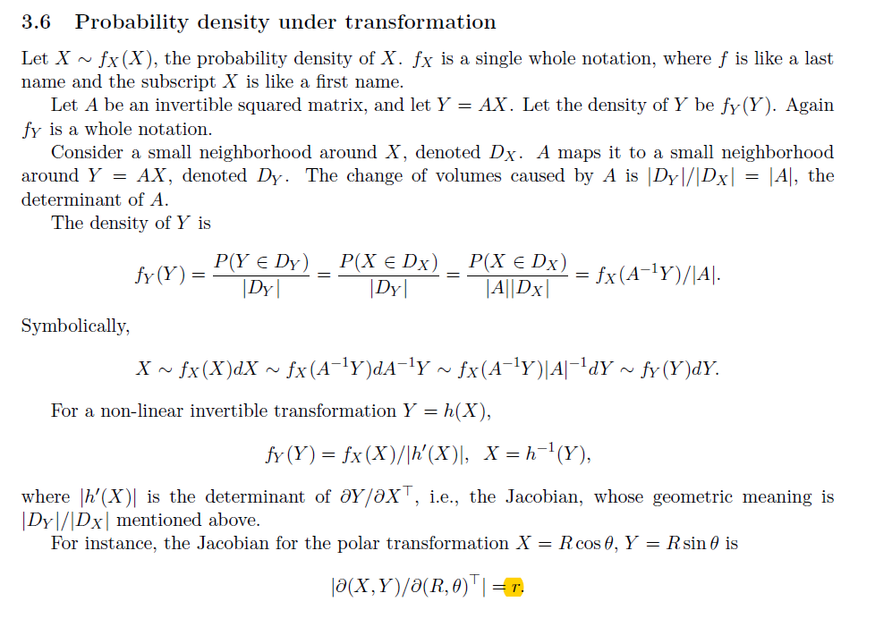

The yellow highlight must be “R” but not “r”.

# Mistake 8

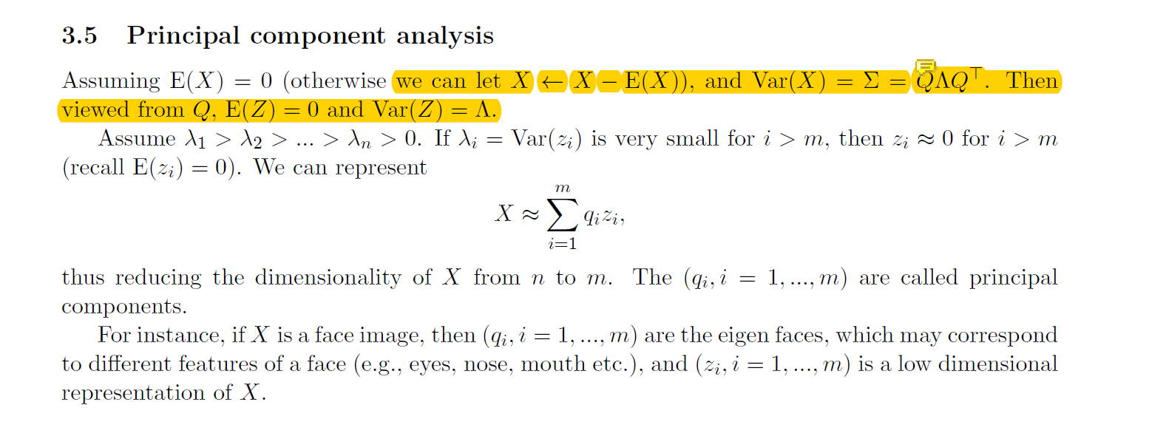

X = QZ must be defined in the paragraph.

# Mistake 9

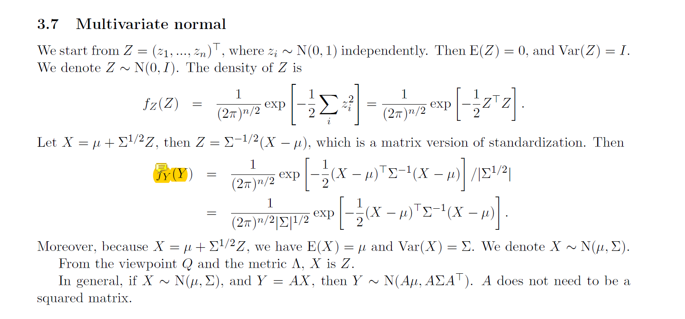

**fY(Y)** 🡪 **fz(Z)**

# Mistake 10

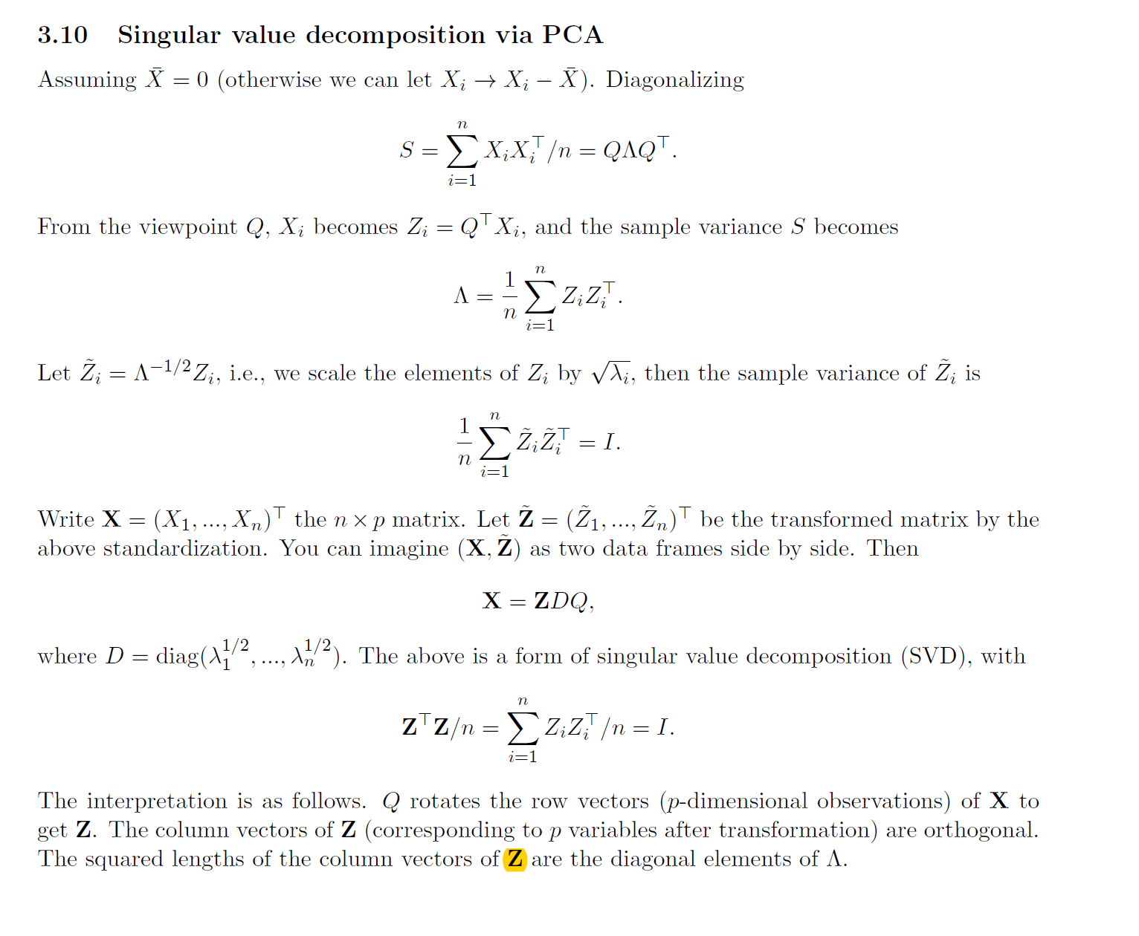

**The squared lengths of the column vectors of Z are the diagonal elements of Λ. 🡪 The squared lengths of the column vectors of D are the diagonal elements of Λ.**